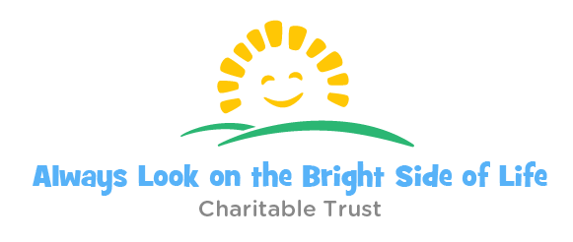

APPLICATION FORM

Data protection:

Our data protection policy is available on our website at: http://www.thebrightsideoflife.org.uk/data-protection/

In summary, we store successful applicants’ data for up to 6 years, and unsuccessful applicants’ data for up to 6 months, following a decision on an application. See the policy for more details.

Please tick this box to confirm you give consent to Always Look on the Bright Side of Life Charitable Trust processing, storing, and using the data you provide as set out in our policy. This is necessary for us to be able to consider your application.

Personal details:

For our reference, we need to know the contact details of the person submitting this application, even if this is the applicant.
Sender's Name (required):
Sender's Email Address (required):
Sender's Connection to Applicant:

Please confirm that the potential beneficiary of this application is under the age of 18 in order to proceed

Applicant's Details
First Name (required)
Middle Name
Family Name (required)
Maiden Name
Any Other Names
Nationality (required)
Date of Birth (required)
Home Phone Number (required)
Mobile Number
Postal Address (required)
Occupation (required)

Parent/Guardian's Details
If you are completing this application form on behalf of the applicant, please complete this section.
Your Full Name
Your Telephone Number
Your Postal Address
Your Email Address
Why are you completing this application form on behalf of the applicant?
Parent/Guardian of applicant aged under 18 Other
If 'Other', please provide further details:

Details of Need
Please provide details of why the applicant is applying for a grant from Always Look on the Bright Side of Life Charitable Trust.
Please include:
* Details of all relevant personal, social, economic, and other circumstances, so that we can make a full assessment of your need(s);
* Specific information on the purpose of the grant. For example, how will the money be spent? Please be as specific as possible. If there is a particular purchase to be made on your behalf please provide details of where this can be purchased, cost, and reason for chosen product;
* The amount of money that you are applying for. Please state whether this will be by way of a grant of money or a purchase on your behalf. Please note that where relevant Always Look on the Bright Side of Life Charitable Trust may prefer to purchase a requested item suitable to your need on your behalf;
* Any other details which you deem relevant.
Enter Details of Need here (required)

Charitable Object of Application
Always Look on the Bright Side of Life Charitable Trust’s charitable objects are:
* Such charitable purposes for the public benefit as are exclusively charitable according to the laws of England and Wales as the trustees may from time to time determine
* To relieve the need of individuals by reason of finance, youth, age or illness by the provision of grants to improve their conditions of life.
Please select which disadvantage applies to the applicant. You may select more than one option:
Financial Youth Age Illness Other
If 'Other', please specify:

Improvement to Applicant's Wellbeing
Please provide details of how a grant made to the applicant, or on the applicant’s behalf, would improve the applicant’s wellbeing, and/or standard of life (required):

Supporting Documents
You may need to submit relevant supporting documents with your application, to be considered for a grant from Always Look on the Bright Side of Life Charitable Trust. *
The documentation we require depends on the disadvantage which forms the basis of your application.
Please attach the following documentation, in accordance with the selection you have made above as to which disadvantage applies to you:
* Financial – please provide a copy of any benefits received, Income Support, Child Support, Tax Credits, Disability Allowance Award, and information on all other financial support that you receive.
* Youth – please provide a copy of the applicant’s birth certificate and another form of identification, for example a passport, travel document, or driving license.
* Age – please provide a copy of the applicant’s birth certificate and another form of identification, for example a passport, travel document, or driving license; and proof of current and completed education, and/or occupation.
* Illness – please provide a copy of the applicant’s medical record and details of any relevant illnesses, ill-health, or other disadvantage to wellbeing.
* Other – please provide copies of any documents that you consider may be relevant to your application.

If there are any further details that you have not included above, and you consider may be relevant to your application, please state these below:

Thank you for completing the Application Form for a Grant from Always Look on the Bright Side of Life Charitable Trust.
Please email your application to: brightsidecharity@hotmail.com

When making decisions on individual applications, Trustees are guided by the Grant-Making Policy, available online at: www.thebrightsideoflife.org.uk. However, all decisions on whether an individual is awarded a grant by Always Look on the Bright Side of Life Charitable Trust remain at the full discretion of the Trustees.
If you need to amend any details once you have completed and submitted this form, or have any further questions, please email: brightsidecharity@hotmail.com

